WebSocket-Based Real-Time LED Control Using ESP32 and MicroPython with 5G WiFi System

Introduction
The rapid growth of the Internet of Things (IoT) has transformed traditional electronic systems into intelligent and interconnected devices. Real-time communication between embedded hardware and web-based interfaces is now one of the most important areas in modern automation systems. Technologies such as WebSocket have significantly improved the capability of microcontrollers to communicate instantly with users over wireless networks.
This project focuses on developing a WebSocket-based LED control system using ESP32 and MicroPython. The system demonstrates how an ESP32 microcontroller can establish a wireless internet connection, host a web server, maintain socket-based communication, and control hardware components in real time through a browser interface.
Unlike conventional HTTP request-response communication methods, WebSocket enables persistent bidirectional communication between the client and server. This allows faster interaction, reduced communication overhead, and real-time control capability. In this project, the ESP32 acts as a lightweight web server capable of receiving commands from a browser and instantly controlling an LED connected to its GPIO pin.
The implementation was developed using MicroPython, a lightweight version of Python designed specifically for embedded systems and microcontrollers. MicroPython simplifies IoT development by providing high-level programming features while maintaining efficient hardware control. The project also demonstrates practical implementation of Wi-Fi connectivity, network configuration, socket programming, and browser-based device control.
The developed system serves as a foundational model for advanced IoT applications such as smart home automation, wireless monitoring systems, industrial control systems, and remote device management. Even though the hardware output is a simple LED, the communication architecture used in this project is similar to those used in complex real-time automation systems.

Objectives
The major objectives of this project are:
- To establish wireless internet connectivity using ESP32 and MicroPython.
- To implement socket-based communication between ESP32 and a web browser.
- To create a lightweight web server hosted on ESP32.
- To control an LED remotely through browser-based commands.
- To understand real-time communication concepts using WebSocket/socket programming.
- To learn MicroPython networking and hardware interfacing techniques.
- To demonstrate the practical implementation of IoT communication systems.
- To develop a scalable architecture for future home automation applications.

Problem Statement
Traditional embedded systems generally require direct physical interaction for controlling hardware devices. Such systems lack flexibility, remote accessibility, and real-time communication capabilities. With the increasing demand for IoT-enabled smart devices, there is a need for systems that can communicate wirelessly and respond instantly to user commands over a network.
Conventional HTTP communication methods create delays because a new connection is established for every request. This limits the efficiency of real-time applications. Therefore, a lightweight real-time communication system was required where an ESP32 could maintain continuous interaction with a client browser while controlling hardware devices efficiently.
This project addresses these limitations by implementing a socket-based communication system using ESP32 and MicroPython. The developed system enables instant LED control through a browser using persistent network communication.

Scope of the Project
The scope of this project includes both hardware and software implementation of a wireless real-time control system. The system can be extended for multiple IoT applications beyond LED control.
Hardware Scope
- ESP32 microcontroller-based communication system
- GPIO control through network commands
- Wireless device management
- Embedded hardware interfacing
Software Scope
- Wi-Fi communication using MicroPython
- Socket programming
- Web server implementation
- Browser-based user interaction
- Real-time command processing
Future Expansion Scope
The same architecture can be expanded for:
- Smart home automation
- Fan and appliance control
- Industrial monitoring systems
- Security systems
- Wireless sensor networks
- Remote laboratory control
- IoT dashboard integration
- Mobile application control

Components Required
Sl. No. | Component Name | Quantity | Description
1 | ESP32 Development Board | 1 | Main microcontroller with Wi-Fi capability
2 | LED | 1 | Output device used for demonstration
3 | Resistor (220Ω) | 1 | Current limiting resistor for LED
4 | Breadboard | 1 | Circuit prototyping platform
5 | Jumper Wires | Several | Electrical connections
6 | USB Cable | 1 | Power supply and programming
7 | Computer/Laptop | 1 | Used for coding and monitoring
8 | Wi-Fi Network | 1 | Required for wireless communication

Working Principle
The working principle of this project is based on wireless communication between a browser and an ESP32 microcontroller using socket programming.
Initially, the ESP32 activates its Wi-Fi station interface and attempts to connect to a wireless network using predefined SSID and password credentials. After successful connection, the ESP32 receives an IP address from the router and becomes accessible within the local network.
The MicroPython program then initializes a socket server on port 80. The socket server continuously listens for incoming client connections from web browsers.
When a user enters the ESP32 IP address into a browser, the ESP32 sends an HTML webpage containing ON and OFF control buttons. When the user presses a button, the browser transmits a request to the ESP32 server.
The ESP32 receives the request, analyzes the command, and determines whether the LED should be turned ON or OFF. Based on the command:
- GPIO pin is set HIGH to turn ON the LED.
- GPIO pin is set LOW to turn OFF the LED.
The server then updates the LED status instantly and maintains continuous operation for future requests. Because socket communication keeps the interaction highly efficient, the response appears nearly real-time.
The project also includes internet connectivity verification using HTTP request testing. The ESP32 sends a request to an external website and checks the response code to verify successful internet access.

Software and Technologies Used
Software / Technology | Purpose
MicroPython | Programming ESP32
Thonny IDE | Code writing and uploading
ESP32 Firmware | Hardware execution
Socket Programming | Real-time communication
HTML | Web interface creation
Wi-Fi Networking | Wireless communication
HTTP Protocol | Browser communication
TCP/IP | Data transmission

Features of the System
- Wireless LED control through browser
- Real-time communication using socket programming
- Lightweight MicroPython implementation
- Embedded web server functionality
- Low hardware requirement
- Fast response time
- Continuous server operation
- Browser-based user interface
- Scalable IoT communication model
- Simple and efficient architecture

Network Communication Architecture
The project follows a client-server communication architecture.
Server Side
The ESP32 acts as the server:
- Connects to Wi-Fi
- Opens socket connection
- Hosts webpage
- Processes client requests
- Controls hardware output
Client Side
The browser acts as the client:
- Sends connection request
- Displays HTML interface
- Sends LED ON/OFF commands
- Receives updated responses
Communication Flow
- ESP32 connects to Wi-Fi.
- ESP32 creates socket server.
- Browser connects using ESP32 IP address.
- HTML control page loads.
- User presses ON/OFF button.
- Request sent to ESP32.
- ESP32 processes request.
- LED status changes instantly.

Wi-Fi Connectivity Implementation
The ESP32 Wi-Fi module was configured in Station Mode. The program activates the WLAN interface and connects to the specified Wi-Fi network using SSID and password authentication.
The implementation includes:
- Automatic Wi-Fi activation
- Network reconnection handling
- Timeout management
- Connection status monitoring
- IP address configuration display
The system verifies connectivity before starting socket communication. This improves reliability and prevents communication failures.

Socket Programming Implementation
Socket programming is the core communication mechanism used in this project. The ESP32 creates a TCP socket server that continuously listens for incoming client requests.
The server implementation includes:
- Socket initialization
- Port binding
- Client connection acceptance
- Request reception
- Command processing
- Response transmission
- Connection termination
This mechanism enables browser-based interaction without requiring additional cloud services or external platforms.

Web Interface Design
The system includes a lightweight HTML interface embedded directly inside the MicroPython code. The webpage contains:
- Project title
- LED status section
- ON button
- OFF button
When accessed from a browser, the interface provides a simple user-friendly control system for hardware interaction.
The HTML response is dynamically transmitted from the ESP32 to the browser through the socket connection.
Code
GitHub Link :- https://github.com/suman1eight9ece24-svg
Result :-
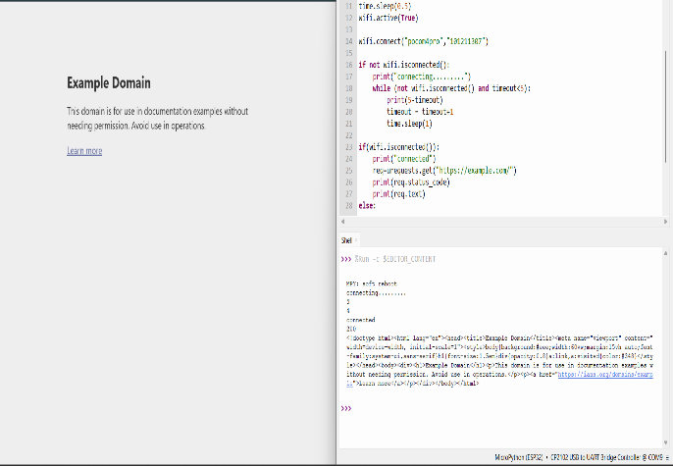
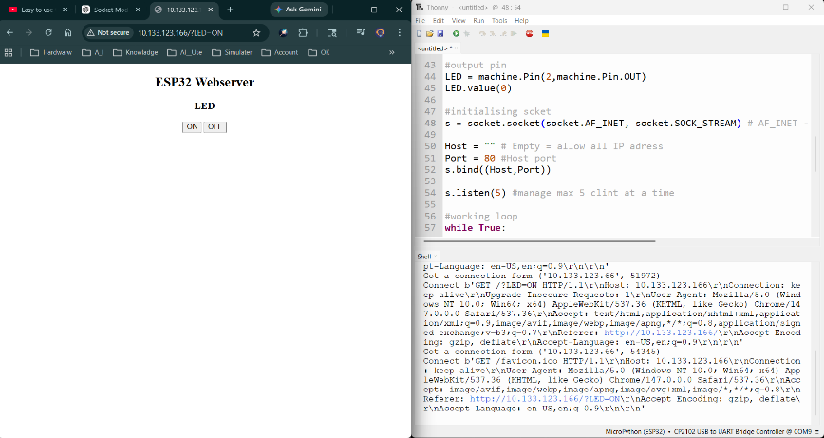
For check result see my “GitHub Account”.

Advantages of the Project
- Low-cost implementation
- Real-time device control
- Wireless operation
- Easy to expand for multiple devices
- Minimal power consumption
- Lightweight software architecture
- Fast communication speed
- Suitable for IoT applications
- Simple browser-based operation
- No external server dependency

Limitations of the Project
- Operates mainly within local network range
- Basic security implementation
- Limited UI complexity
- Single-device demonstration
- Depends on stable Wi-Fi connection

Applications
This project can be applied in:
- Smart home automation
- Wireless lighting systems
- Industrial control systems
- IoT laboratories
- Remote appliance control
- Educational embedded system projects
- Real-time monitoring systems
- Wireless switch replacement systems
- Automation training modules

Future Improvements
Several advanced features can be added in future versions:
- Real WebSocket protocol implementation
- Mobile application integration
- Authentication and security system
- Cloud connectivity
- MQTT protocol support
- Multiple device control
- Sensor data monitoring
- Voice assistant integration
- Real-time dashboard system
- Database logging

2️⃣1️⃣ Conclusion
The “WebSocket-Based LED Control System Using ESP32 and MicroPython” successfully demonstrates the implementation of real-time wireless communication for embedded systems. The project integrates Wi-Fi networking, socket programming, MicroPython scripting, and hardware control into a single IoT-based system.
Through this project, a lightweight web server was developed using ESP32 capable of receiving browser commands and controlling hardware output in real time. The implementation proves that MicroPython is highly effective for rapid IoT development while maintaining simplicity and efficiency.
Although the project demonstrates LED control as a prototype, the underlying communication architecture is powerful enough to support advanced automation systems. The concepts learned in this project form a strong foundation for developing future IoT applications such as smart homes, industrial automation systems, and wireless monitoring platforms.
The project also provides practical understanding of:
- Embedded networking
- TCP/IP communication
- Socket programming
- Wireless device control
- Browser-server interaction
- MicroPython-based IoT development
Overall, the project successfully achieves its objectives and demonstrates a reliable approach for real-time IoT communication using ESP32 and MicroPython.

